Fisa tehnica
Sandale AMSTERDAM

Cod: 2865-O1

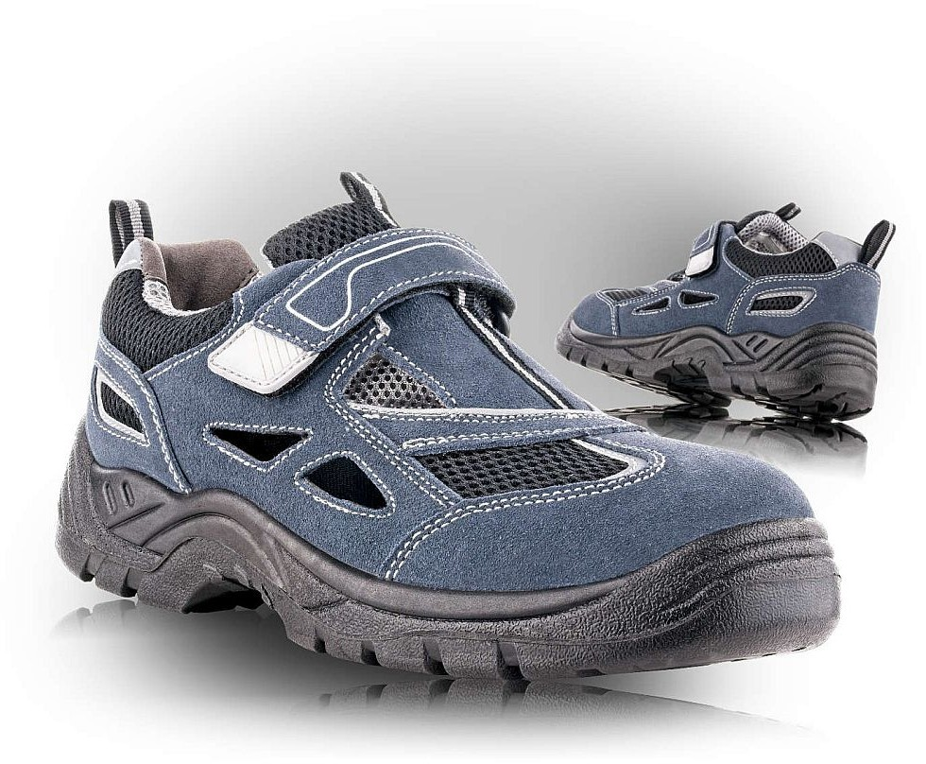

Exterior Velur grosime 1,6 – 1,8 mm
Interior Tesatura laminata respirabila Mesh
Talpa Poliuretan rezistenta la hidrocarburi, antialunecare, antistatica
Marimi 36 – 48
Standard EN ISO 20347:2012
Clasa O1 FO E SRC – fara bombeu

Greutate
Marime | Greutate neta | Greutate bruta
36 | 0,75 kg | 0,98 kg
37 | 0,76 kg | 0,99 kg
38 | 0,80 kg | 1,04 kg
39 | 0,81 kg | 1,05 kg
40 | 0,82 kg | 1,05 kg
41 | 0,88 kg | 1,11 kg
42 | 0,90 kg | 1,13 kg
43 | 0,91 kg | 1,17 kg
44 | 0,96 kg | 1,21 kg
45 | 0,99 kg | 1,24 kg
46 | 1,01 kg | 1,27 kg
47 | 1,04 kg | 1,31 kg
48 | 1,06 kg | 1,35 kg

Cod tarifar 6403999
Tara de origine CN

